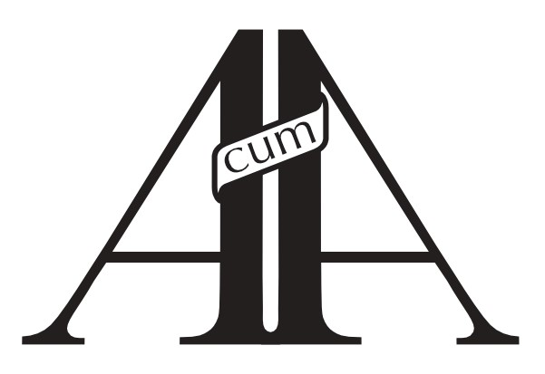 ASTON-CUM-AUGHTON
PARISH COUNCIL

12 June 2025

JOB VACANCY
GATEKEEPER (Part-Time)

Aston-cum-Aughton Parish Council is seeking a reliable and punctual individual to take on the role of Gatekeeper. The successful candidate will be responsible for the opening and locking of the gate at one of our premises.
This part-time role is ideal for someone looking for a few hours of work each week, with the potential for additional hours as required.
Minimum of 4 hours per week
Hourly rate: £12.21

If you are interested in this role or would like more information, please contact the Clerk to the Parish Council:
Tel: 0114 287 9008
Email: clerk@aston-pc.gov.uk
Closing date: Friday 27 June 2025

